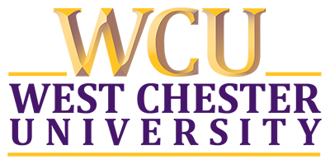
Fall 2023 Bus Trip to Harlem, New York
with
The Fredrick Douglass Institute

Event Date: Wednesday, October 18, 2023
Departure Time: 7:00 am, Wells School of Music

I _______________________ acknowledge I am paying a non-refundable $15.00 fee for the Frederick Douglass Institute Bus trip to DC that will be used toward breakfast and tipping the bus driver(s).
I also acknowledge that this is a West Chester University-sanctioned trip and I will follow the same rules of WCU while off campus on this trip.

Signature Date

