Business and Public Management Center

50 Sharpless Street
Built: 2016 | Size: 96,090 sf
Acquired: | Condition: Excellent
Last Renovation: | Function: E&G


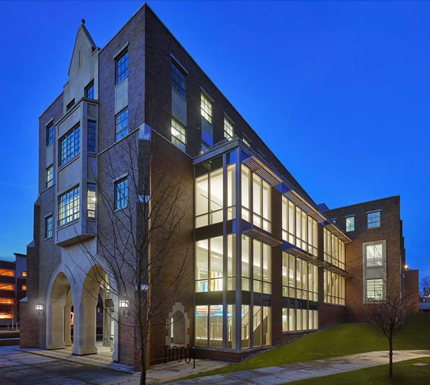
This recently constructed new academic building sits on the site of the previous McCarthy Hall, and flanks the northern informal entrance to campus via South Church St. Its Collegic Gothic architectural style, designed by Voith and MacTavish Architects, reflects the original design vernacular of the original 19th Century buildings on campus, and serves as a bridge between the past and the future of the university.
As the campus’ largest academic building, it houses the College of Business and Public Management classrooms, labs and faculty and Dean’s offices. The exterior of the building sports a multi-level rain garden, part of its gold-LEED construction rating.

Present Use: Classrooms, labs and faculty/staff offices. Academic Departments include Accounting, Economics, Management, Marketing, Political Science, and Geography and Planning.

Disability Access: Full

Past Projects: None

Scheduled Projects or Capital Renovations: None

Description of Construction: Reinforced concrete foundation, steel skeleton with poured concrete floors, masonry exterior skin.

Condition and Use Assessment:
Deferred Maintenance (2006): $0 | Est Replacement Cost (2006): $
Facility Condition Index: 0. | Deficiency/SF: $
Yearly Electric Use Cost: $ | Yearly Water Use Cost $

