
Tyson Hall

225 N. Campus Drive
Built: 1966 | Size: 121,959 sf
Acquired: N/A | Condition: Fair
Last Renovation: 1993 | Function: AUX

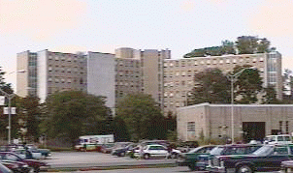

Tyson Hall is located along Sharpless St, and is a sister building to Goshen Hall- they were constructed at the same time with almost identical plans including exterior finishes, room arrangement and amenities with include a central student lounge and a large laundry on very floor, two large recreation rooms with a small kitchen for student use, and a large covered terrace.

Tyson Hall is in poor condition and in need of extensive renovation. This building is scheduled to be demolished and replaced with a suite-style residence hall, in the near future.

Present Use: Residence Hall

Disability Access: Full, with ramps and automatic doors at both entrances.

Past Projects: 1993 Renovation, 1997 Elevators, 2000 Furniture, 2001 Roof, 2002 LAN/Telephone/CATV, 2004 Sprinklers-Fire Alarm, 2005- 2006 Shower Pan replacements, paint and carpet.

Scheduled Projects or Capital Renovations: Demolition

Description of Construction: Reinforced concrete foundation and structure, built-up roof, masonry brick veneer exterior walls, concrete slab floors.

Condition and Use Assessment:
Deferred Maintenance (2007): N/A | Est Replacement Cost (2007): $ 24,875,000
Facility Condition Index: 0. | Deficiency/SF: $
Yearly Electric Use Cost: $ | Yearly Water Use Cost $

