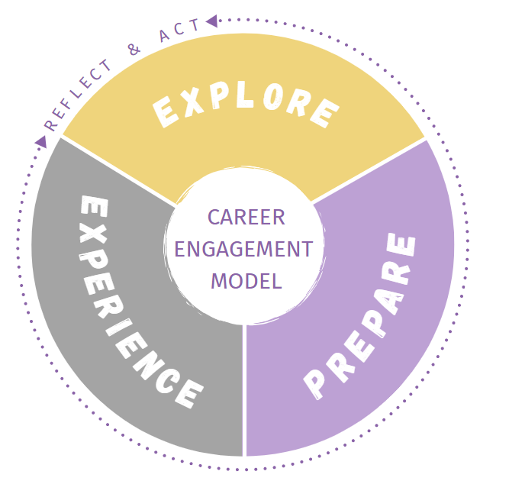As you ***explore* careers**, it can be helpful to take note of certain information relating to each career that you are considering. Answer the following questions to begin researching fields of interest. Resources like onetonline.org and bls.gov/ooh will help you in your exploration:

**Name of Career: ______________________________________**

* What are a few daily tasks for this position?
* What education and training are required?
* What types of industries employ people with this type of job?
* What knowledge, skills, and abilities are needed to succeed in this career path?
* What is an average salary?
* What interests you most about this career?
* What concerns do you have about this career?
* What are some related careers?
* Who could you talk to and where else could you look to learn more about this career?