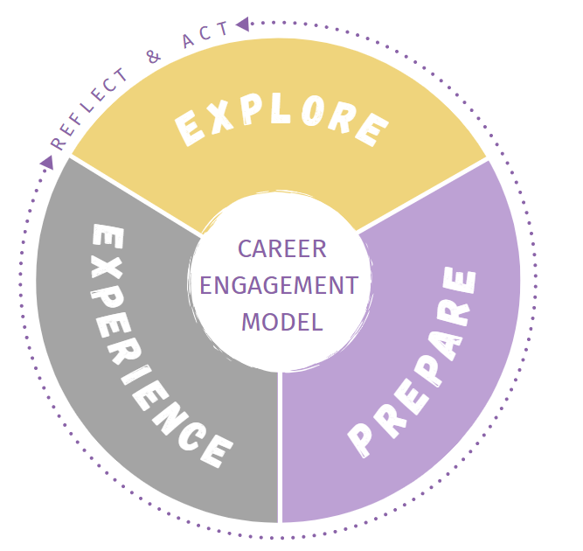
As you explore majors, it can be helpful to take note of certain information relating to each major that you are considering. Complete the following information for 3-5 of the majors that are of interest to you:

Name of Major: _____________________________________

- List any concentrations/tracks within this major:

- What are some of the topics and information covered in this major?

- What are some of the required courses in this major?

- What are other requirements of this major (labs/field experience/ internships/etc.)?

- What is a student organization related to this major?

- What interests you most about this major?

- What concerns do you have about this major?

- List any careers you believe you could pursue with this major. Hint: Major does NOT equal career.
Check out ‘What Can I do with this Major’ resource listed on CDC website.

- Who could you talk to and where else could you look to learn more about this major?

