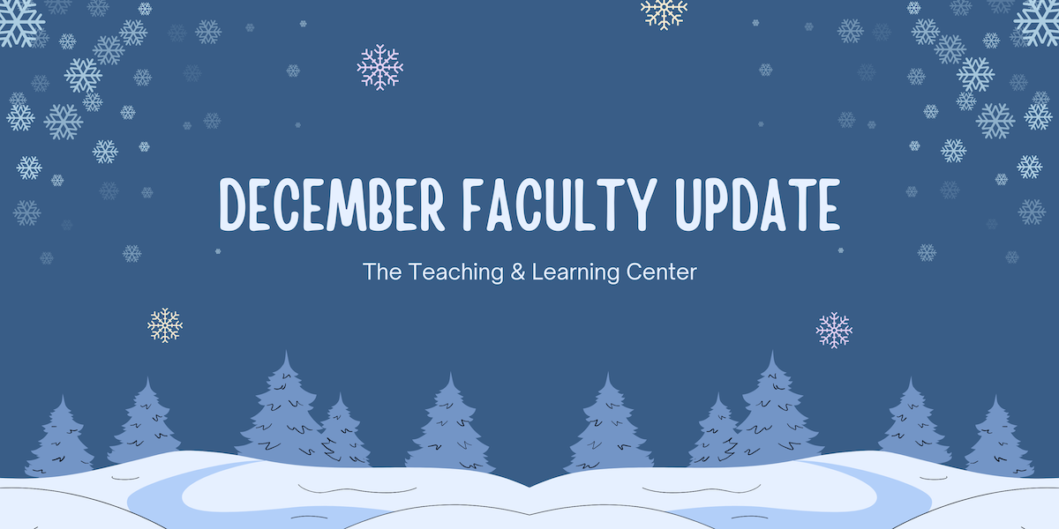

With 2024 coming to a close, this will be our final newsletter of the year. Thank you for being part of our community of educators — we look forward to connecting with you again in the new year! From all of us at the Teaching & Learning Center, have a joyful and restful holiday season.

# Open Calls & Initiatives

## (Due Dec 9) Faculty Survey: Open Educational Resources at WCU

As the cost of textbooks and other educational materials continues to rise, faculty have been turning to [Open Educational Resources (OER)](https://www.wcupa.edu/tlc/oer.aspx) as a solution to keep student costs down and bring equity to their courses, and the Teaching & Learning Center and University Libraries currently offer a variety of programs, resources, and services to faculty who are interested in OER.

To inform our decisions about future OER-related efforts, the TLC and University Libraries are working together to create and distribute a [survey to better understand how WCU faculty use, create, and adapt these materials](https://wcupa.co1.qualtrics.com/jfe/form/SV_2oipSY4e1IJZqui). The survey will close on **Monday, December 9.** To learn more, visit [the TLC blog](https://wcu-tlc.org/etextbook/faculty-survey-open-educational-resources-at-wcu/).

## (Due Jan 31) Teaching Triangles for the Spring Semester

The Teaching Triangles program involves three faculty members in a triad who agree to visit each other’s classes over the semester and meet to discuss what they have learned about their own teaching from the observations. The process is non-evaluative, and the program is open to all WCU faculty, including adjuncts. Learn more about the program [on our website](https://www.wcupa.edu/tlc/flc.aspx) or [from our podcast, ODLI on Air](https://open.spotify.com/episode/7EVYwGZvoqtNBIDy4jiaDa?si=w5eFVVtcRCW6k0ulgMs-rw&nd=1&dlsi=7e683d93f8334283). If you're interested, [apply online](https://wcupa.co1.qualtrics.com/jfe/form/SV_02LR8pktqgLt5ye) by **January 31, 2025.**

## (Due Mar 1) 2025-26 CELT Professional Development Award

The Committee for Excellence in Learning and Teaching offers an annual professional development award for up to $2,000 for pedagogical and curricular innovations leading to student success. These funds are to encourage the implementation of new and innovative projects that would not be possible without this financial support. Up to four projects will be selected for funds up to $2,000 per project.

Proposals are due **March 1**. For more information, [visit our blog](https://wcu-tlc.org/pd/celt-announces-2025-26-professional-development-award/) or [review the full guidelines](https://wcupa.sharepoint.com/:b:/s/AA/ded/ESAqPAmosp5LnL_7nKzK9r8Bhdj2DGHeeoYrboP8zLGNGg?e=TXoDJf); if you have any questions, please reach out to CELT Faculty Associate Janneken Smucker ([jsmucker@wcupa.edu](mailto:jsmucker@wcupa.edu)).

## (Ongoing) Psychological Safety of Higher Education Faculty Study

Kelly Fisher and Tom Pantazes, with support from Anita Foeman, are conducting an anonymous survey of WCU faculty's psychological safety in the classroom. They are specifically interested in how faculty members’ identity and visible/invisible disabilities influence their relationship with students and teaching approach based on the strength of their felt psychological safety. Participants will also have the option to engage in a 60 - 90 minute one-on-one or focus group interview. The results will help inform our understanding of West Chester University’s campus psychological safety.

The researchers invite you to participate in this study by completing the [Psychological Safety of Higher Education Faculty survey](https://wcupa.co1.qualtrics.com/jfe/form/SV_en6ljaa9YhoQwDQ). This study has been approved by the West Chester University Institutional Review Board, protocol IRB-FY2024-286. Your participation is most appreciated.

## (Ongoing) Willing to Share Your Experience Working with Generative AI?

The TLC is looking for individuals interested in delivering 15 minute, recorded webinar presentations connected to one of these four themes:

1. Getting started with Generative AI tools
2. Academic honesty and what original work means in your discipline
3. Creating an AI policy with students
4. Building real world assignments in an AI age

Complete our [interest form](https://wcupa.co1.qualtrics.com/jfe/form/SV_1YVWtISHaJVHo22) and a member of the TLC will be in touch. If you have any questions, please contact us at [tlc@wcupa.edu](mailto:tlc@wcupa.edu?subject=).

# Upcoming Events

## (In-person: Dec 10 – 12) You Have to Try AI Before You Guide AI

Are you looking for some dedicated time to explore generative AI tools? If so, join TLC staff for an hour (or more) during finals week to play in the proverbial AI sandbox in Anderson 125. We will explore tools such as ChatGPT, Microsoft CoPilot, Claude, Google LM notebook, Perplexity, Sonora, and more. Bring your laptop and any AI tools you want to try!

Sessions occur at 10 am, 11 am, 1pm and 2pm on:

* **Tuesday, December 10**
* **Wednesday, December 11**
* **Thursday, December 12**

[Pre-registration](https://wcupa.co1.qualtrics.com/jfe/form/SV_0GwF6kget8RyLxY) is appreciated, but not required.

## (In-person: Dec 16) Applying the Quality Matters Rubric (APPQMR) Workshop

This full day, in-person workshop will renew your CAPC Distance Education Training Credential and award you the official Quality Matters APPQMR Certificate of Completion. It is facilitated by WCU instructional designers. The training will be held on **Monday, December 16** from 8:30am to 4:00pm; participants must attend the whole day. Complete the [APPQMR Interest Form](https://wcupa.co1.qualtrics.com/jfe/form/SV_8kn2OJpAqrkfi4u), and a member of the TLC will be in contact a few weeks prior to the workshop with location information. Space is limited.

## (In-person: Jan 15) Faculty Fusion 2025: Register Now

Need help transitioning out of holiday mode before the Spring semester? Looking for ways to keep Winter class momentum rolling? Register today for [Faculty Fusion](https://wcupa.co1.qualtrics.com/jfe/form/SV_bwlIauASAIiDAii)!

* **When:** **January 15, 2025** from 9:00 am to 1:00 pm
* **Where:** The Foundation
* **What:** An in-person set of three interactive panels covering hot topics to help you prepare for the new semester.

Panel topics include:

1. Fostering Student Agency, Ownership, and Leadership
2. Innovative Teaching, Impactful Research: Transforming Classroom Practices into Scholarship
3. Matching Accommodations to Reality - Strategies to Help Faculty meet Student Needs

Each session has 30 minutes of presentation from a faculty panel followed by 20 minutes of Q&A and table conversations with your peers. To learn more, visit the [event blog post](https://wcu-tlc.org/pd/2025-faculty-fusion-hot-topics-with-the-tlc/), or reach out to [tlc@wcupa.edu](mailto:tlc@wcupa.edu?subject=) with any questions.

## (Virtual) Faculty Mentoring Committee Announces Two Spring Events

The Faculty Mentoring Committee and Teaching and Learning Center invite you to our Spring 2025 Events! Ramp up your career with these powerful panels. Attend one or both! *ALL faculty are welcome!*

**SCHOLARLY PRODUCTIVITY PANEL**  
**Thursday, January 30** from 12:30 to 1:30 pm

Engage with a panel of productive scholars from each college and learn to improve your productivity. [RSVP and submit questions for the productivity panelists](https://wcupa.co1.qualtrics.com/jfe/form/SV_e4bTwT52mYwMG5o) today!

**PROMOTION PANEL**

**Thursday, February 20** from 12:30 to 1:30 pm

Come talk with a panel of professors who have recently been through the promotion process. All levels of promotion will be addressed. [RSVP and submit questions for the promotion panelists](https://wcupa.co1.qualtrics.com/jfe/form/SV_9uaE6skVzpQFKf4) today!

Questions? Contact Ralph Sorrentino ([rsorrentino@wcupa.edu](mailto:rsorrentino@wcupa.edu)) or Michelle Blake ([mblake@wcupa.edu](mailto:mblake@wcupa.edu)), Co-Chairs of the Faculty Mentoring Committee.

## Coming Soon: Quality Matters Summer Camp

In an effort to streamline the Quality Matters course review and certification process, we are consolidating our year-long initiative into a three-week QM Summer Camp from **June 2 to June 20, 2025**. This streamlined model will facilitate collaboration within a cohort, consolidate the work to prepare your course, and allow you to focus on your teaching during the academic year. At the end of summer camp, you can have one course ready for a Quality Matters course review. Faculty who earn QM certification are eligible for a stipend. More information and applications to come in Spring 2025.

# Program Updates

## NEW! D2L Module Page Templates Now Available in Course Design Resources Site

We are pleased to announce that the D2L Course Design Resources Site now includes a library of module page templates available to all WCU faculty for use in their courses. These templates can be copied into any course and used to create professional and engaging course module pages. Visit the [D2L Course Design Resources Site](https://d2l.wcupa.edu/d2l/home/3691882) to learn more. If you have any questions about the D2L Course Design Resources Site, contact the TLC at [tlc@wcupa.edu](mailto:tlc@wcupa.edu?subject=).

## Online Faculty Development Program

Need to earn or renew your CAPC distance education credential? Faculty can now self-enroll into the OFD program’s D2L site using the [Discover feature](https://wcupaprod.service-now.com/kb?id=kb_article_view&sysparm_article=KB0010869)! Start working whenever it fits your schedule.

# Stay Connected

## ODLI on Air Celebrates 50 Episodes

[Creating Pottery Using Chat GPT with Andrew Snyder](https://wcu-tlc.org/podcast/creating-pottery-using-chatgpt-with-andrew-snyder-podcast/) was ODLI on Air's 50th episode! Give it a listen, or tune in to [Indigenous Pedagogies with Joey Miller](https://wcu-tlc.org/podcast/indigenous-pedagogies-with-dr-joey-miller-podcast/). Whether you're exploring new teaching strategies, seeking inspiration, or staying updated with the latest on campus, ODLI on Air has something for everyone.

## Connect with Us

The Teaching and Learning Center is far more than just a newsletter! Our website hosts a variety of [teaching resources](https://www.wcupa.edu/tlc/teaching-resources.aspx) and our full [Event Calendar](https://www.wcupa.edu/tlc/events.aspx). To get in touch, feel free to [send us an email](mailto:tlc@wcupa.edu?subject=), or stop by our [drop-in hours](https://www.wcupa.edu/tlc/drop-in.aspx) to speak live with one of our designers.