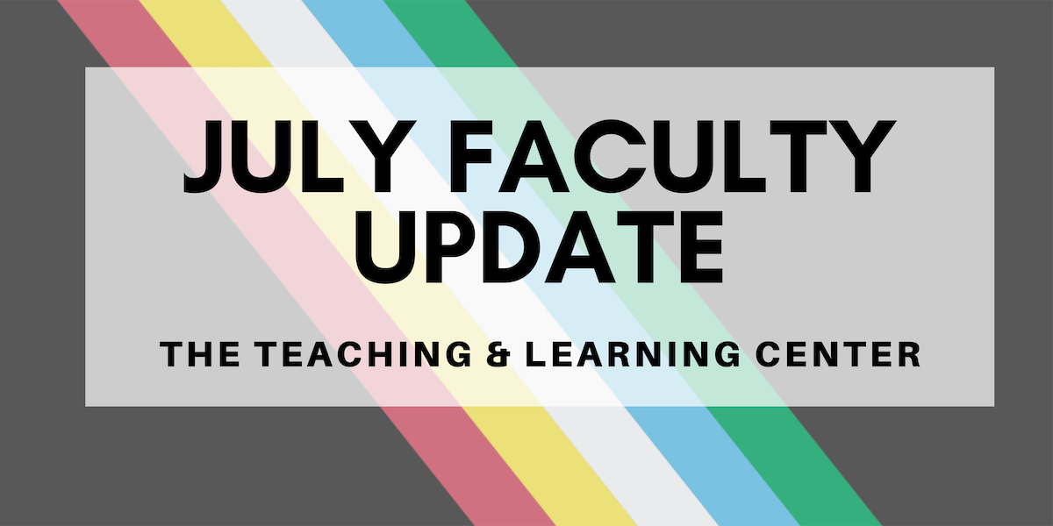

July is Disability Pride Month, a time to celebrate the abilities and achievements of the disability community! This year, there's been an important update to the Americans with Disabilities Act (ADA) calling for an increased commitment to digital accessibility: watch this space for more information about what that means for West Chester University. To be proactive, review our Navigating Digital Learning tutorials to learn about what digital accessibility means, or reach out to your instructional designer for personalized support.

Open Calls & Initiatives

(Due Aug 12) Faculty Focus Group
The Teaching and Learning Center, in partnership with D-CAP and ODEI, is planning a new initiative, tentatively named Inclusion Matters, with the intent of bolstering the success of historically marginalized students. The idea behind ‘Inclusion Matters’ is to employ an intersectional approach to creating inclusive and welcoming learning environments for all students at WCU. The team is holding two focus group sessions to gather information from faculty and staff about their experiences working with our diverse student body to better tailor the content to fit your needs. To share your experiences, register today!

(Due Aug 15) Program for Excellence in Teaching & Learning (PETAL)
PETAL (Program for Excellence in Teaching and Learning) invites you to participate in a semester-long experience! Join fellow educators in weekly conversations and reflections on teaching excellence. This program, sponsored by the Provost, is open to all incoming faculty and a limited number of current faculty members. Learn more about PETAL on our website. Applications are due by Thursday, August 15.

(Due Sep 5) PASSHE Summit: Call for Proposals
The 2024 PASSHE Summit is currently seeking proposals from faculty, staff, and students about how to cultivate and maintain environments that promote inclusive student success. The Summit will be held on October 28 & 29 in a hybrid format, with in-person sessions at Millersville University and virtual sessions on Zoom. Additional details can be found in the full Request for Proposals, and any questions can be directed to Summit co-chairs Christa Cobb (ccobb@passhe.edu), emily howe (ehowe@passhe.edu), and Carlos Wiley (carlos.wiley@millersville.edu). Proposals can be submitted online until Thursday, September 5.

(Fall 2024) CELT Book Club
It’s time to register for the Committee for Excellence in Learning and Teaching’s Fall 2024 Book Club! We invite you to join CELT in reading and discussing José Antonio Bowen and C. Edward Watson’s Teaching with AI: A Practical Guide to a New Era of Human Learning (2024). To participate and receive a complimentary copy of the book, you must commit to attending two meetings throughout the semester: one in October and one in November.

After registering online, you may pick up your copy from the Teaching and Learning Center on Tuesdays or Thursdays starting on August 6. If you have any questions, please contact book club leaders Dawn Patterson (dpatterson@wcupa.edu) and Jenn Raskauskas (jraskauskas@wcupa.edu).

(2024-25) Faculty Mentoring Committee: Call for Mentors
Are you looking for a University service opportunity? Do you want to make a significant difference in a colleague's career development? Do you want to increase your own job satisfaction? Consider becoming a mentor to your fellow faculty!
The Faculty Mentoring Committee is looking for mentors for faculty at three career stages. Tenured faculty and individuals who have participated in the adjunct faculty mentoring program for at least two semesters are invited to apply. For more information, please see the full call for mentors, or apply online.

Upcoming Events

(Aug) Classroom Technology Practice Sessions
Multimedia Services invites you to attend a 45-minute practice session to learn about the classroom audiovisual technology that West Chester University offers. Learn the best practices for utilizing the technology to engage your students, with a chance to ask questions and get some hands-on experience before the semester begins. For a list of dates and additional resources, see the event flyer.

Program Updates

New D2L Course Design Resources Site
We are pleased to announce the launch of the D2L Course Design Resources Site, which is now available for all WCU faculty. This site is hosted in D2L and is designed to support course creation and enhancement efforts by providing easy access to essential tools and templates. The site currently includes:
- A Library of Pre-Designed D2L Homepage Templates: These customizable templates can be copied to any course to help instructors set up a professional and engaging course homepage quickly and efficiently
- Creator+ Resources: Creator+ is a new tool available in D2L that allows instructors to easily add dynamic content and interactive activities directly to their course module pages.
You can access the D2L Course Design Resources Site from the Resources tab on the homepage of D2L, or by following this link: D2L Course Design Resources Site. If you have any questions about the D2L Course Design Resources Site, please contact the TLC at tlc@wcupa.edu.

New Netiquette Resource for WCU Courses
The TLC is pleased to announce the development of a new, updated Netiquette explanation! This document provides brief explanations of each concept introduced, as well as citations. We invite all faculty to provide this document as a resource in your online courses to help students understand what is expected of them when engaging in online dialogues. The updated version replaces the old Netiquette document, which will be retired on July 1: if there are any links to the old document in your courses or syllabi, be sure to update them in advance to prevent confusion.

Spring 2024 Pilot Findings and Next Steps: D2L Homepages
Thank you to everyone who participated in the Spring 2024 Pilot Program, Efficiency Meets Design: D2L Homepages Made Easy! For your convenience, we have put together this one-page report on findings from this pilot and next steps. For a more detailed look at the data, check out the full report. If you have any questions about this report, please contact the Teaching & Learning Center at tlc@wcupa.edu.

PA-ADOPT: New eTextbooks Published
The PA Alliance for Design of Open Textbooks is pleased to announce the availability of two new free and open textbooks: Basic Statistics Using R for Crime Analysis by Dr. Jaeyong Choi, Associate Professor of Criminal Justice, and Introduction to Data Science Using Python by Dr. Afrand Agah, Professor of Computer Science. To learn more, check out our blog!

Online Faculty Development Program
Need to earn or renew your CAPC distance education credential? Faculty can now self-enroll into the OFD program’s D2L site using the Discover feature! Start working whenever it fits your schedule.

Stay Connected

ODLI on Air Podcast
Season 4 wrapped up last month with part 2 of our AI conversation with Eryn Travis and a discussion on open science resources with Dr. Megan Fork and student Jessica Buchser. The podcast takes a break from its regular every other week publishing schedule over the summer, making it a great time to catch up on episodes you might have missed! We'll be back with Season 5 on August 30, 2024.

Connect with Us
The Teaching and Learning Center is far more than just a newsletter! Our website hosts a variety of teaching resources and our full Event Calendar. To get in touch, feel free to send us an email, or stop by our drop-in hours to speak live with one of our designers.

